

|  |
| --- |
| Zomato  Data  Analysis |
| Customer Analysis Segmentation |
|  |
| Luke Patrick | Triple Ten BIA Final project | February 2025 |

# Contents

Contents 0

1. Introduction 1

2. Methodology 2

3. Findings 3

Customer Segmentation Overview: 3

User Demographics by Income and Occupation: 5

Restaurant Ratings, Income Segments, and Their Influence on Ordering Behavior: 5

Sales by Family Size: 9

4. Conclusions and Recommendations 10

5. Appendix 12

Data Sources: 12

References 12

# 1. Introduction

Objective

To analyze Zomato's customer base, segment customers into meaningful groups, and understand their purchasing behavior to enhance marketing strategies and customer satisfaction.

Research Questions

1. Who are Zomato’s customers, and how do their demographics influence purchasing behavior?
   * Customers can be segmented by demographics such as income levels, age brackets, family size, and occupation.
   * Hypothesis:
     1. Younger customers may have lower average order values than older customers.
     2. Orders from larger families result in higher sales than single person households.
2. How can we segment other data to research customer purchasing behavior?
   * Segmentation based on order frequency, order value, and restaurant ratings.
   * Hypothesis: Younger customers may prefer more affordable restaurants, while older customers are less price sensitive.
3. What are the key characteristics and behaviors of each segment?
   * Identification of distinct traits, preferences, and tendencies within each segment.
   * Hypothesis: Customers with lower monthly incomes prefer more affordable restaurant options compared to higher-income customers.
4. How do different customer segments interact with Zomato’s services?
   * Analyzing engagement levels, frequency of repeat purchases, and loyalty to specific restaurants.
   * Hypothesis: Customers are more likely to order from higher-rated restaurants.
5. What are the purchase patterns and preferences within each segment?
   * Analyzing price sensitivity and order consistency.

# 2. Methodology

This analysis is based on publicly available Zomato customer data, which includes user demographics, income segments, and purchasing behavior. The dataset was processed and analyzed using Tableau to identify key trends in customer segmentation and restaurant selection. Various visualizations, including bubble charts and bar graphs, were utilized to illustrate user distribution across occupations and income levels.

Key analytical techniques included:

* **Segmentation Analysis**: Users were categorized by income level and occupation to determine behavioral patterns.
* **Purchasing Behavior Trends**: The frequency of orders, spending habits, and restaurant ratings were assessed to understand customer priorities.
* **Business Implications**: Findings were translated into actionable insights to inform Zomato’s marketing and engagement strategies.

This approach ensures data-driven conclusions that can support targeted business strategies for different customer groups.

Full details of data transformations and specific segmentation methodologies can be found in the supplemental section attached with this report.

# 3. Findings

## Customer Segmentation Overview:

**Age Groups:**

Figure 1

* The **Younger Customer** category includes ages 18 to 24 with a total of **179,883** users.
* The **Older Customer** category includes ages 25 to 33 with a total of **142,750** users.
* Younger customers make up a slightly larger portion of the user base **(55.7%)** compared to older customers **(44.3%)**
* The peak customer age is 23 years (**60,419** users).
* The largest number of older customers is at age 25 (**43,683** users) and gradually declines as age increases.

**Monthly Income:**

Figure 2

* The largest user group falls under the "**No Income**" category, significantly surpassing all other segments. This could indicate a high number of students, unemployed individuals, or financially dependent users.
* **Mid-Level** and **High-Income** segments are substantial. These segments have a considerable number of users, though they are much lower than the **No Income** category. These users likely have stable financial resources, potentially affecting their purchasing behavior.
* **Low Income** has the smallest user count, while **Modest Income** is slightly higher but still on the lower end, suggesting that users with minimal disposable income may be underrepresented or less engaged.

**Occupations:**

Figure 3

* The largest segment by far consists of **Students**, indicating that a sizable portion of users are young individuals who might have **limited income** and **high digital engagement**.
* **Professionals** are the second largest group, suggesting a substantial working-class user base that may have **stable incomes** and **predictable** spending habits.
* **Entrepreneurs** make up a moderate portion of the users, and the smallest segment consists of homemakers. They may be interestedin **value-for-money offerings** or services that cater to **convenience** and **efficiency**.

**Family Sizes:**

Figure 4

* Single family households comprised the smallest segment.
* Two and three family member households made up much of the user base.

## User Demographics by Income and Occupation:

Figure 5

* Students form the largest user base, mostly with no or low income, confirming that most students are financially dependent. This aligns with the income segment analysis, where "no income" had the largest representation.
* Professionals are more financially diverse and are well distributed across income levels. This group will likely have more disposable income and purchasing power.
* Entrepreneurs are primarily in higher income brackets with no representation in the "no income" or "low income" categories. This suggests that entrepreneurs in this dataset have established businesses.
* Homemakers are a small but notable segment with no income. Their engagement may be more influenced by household needs, family-oriented purchases, or shared financial decision-making.

## Restaurant Ratings, Income Segments, and Their Influence on Ordering Behavior:

Overview of Sales Distribution by Income Segment

* A pie chart with numbers and text

  AI-generated content may be incorrect.The **No Income** segment accounts for the largest share of total sales.

Figure 6

* **Mid-Level and High-Income segments** have similar median order values but generate lower total sales due to fewer transactions.

Median Order Value by Income

Figure 7

* All segments have fairly similar median order values **(~$5.80-$5.93)**
* Suggests that **order frequency,** rather thanorder value, is the **key differentiator** in total spending.
* Despite higher spending power, **higher-income groups do not place significantly larger orders**.
* Sales dominance by the **No Income** group is driven by **order volume** rather than order size.

The Role of Restaurant Ratings in Ordering Behavior

* **Income Distribution**
  + The largest segment (48%) is **No Income** individuals. A screenshot of a computer screen

    AI-generated content may be incorrect.

Figure 8

* + A majority of every income group tends to order from restaurants with **no ratings** (59%). This suggests that most customers either do not consider ratings when choosing a restaurant or ordering from places that have not been widely reviewed.

Figure 9

* + **Higher-income** groups are more likely to order from **highly-rated** restaurants, but even they contribute significantly to unrated restaurant sales.
  + This implies that **price sensitivity** **and restaurant accessibility** could play a role in purchasing decisions.

Overall Ratings Count Distribution by Occupation Segment:

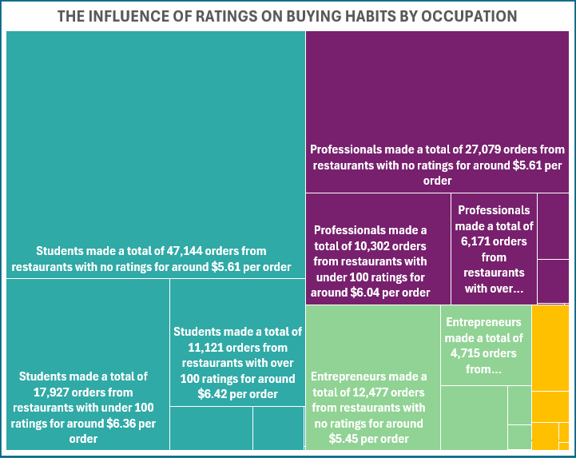

Homemakers made a total of 2,055 orders from restaurants with no ratings for around $5.56 per order

Figure 10

* **Students have the highest order frequency overall**, but a disproportionate number of their orders come from unrated restaurants.
* **Entrepreneurs show a rare but significant trend**—those ordering from **highly-rated restaurants (over 10K ratings)** have a **much higher median order value ($101.33)**, suggesting that when they do choose premium establishments, they spend significantly more.
* **Professionals and homemakers** exhibit a balanced spread across rating levels, but homemakers engage **less frequently with highly-rated restaurants**, likely due to different household purchasing dynamics.

Correlation to Order Frequency vs. Restaurant Cost Segment

Figure 11

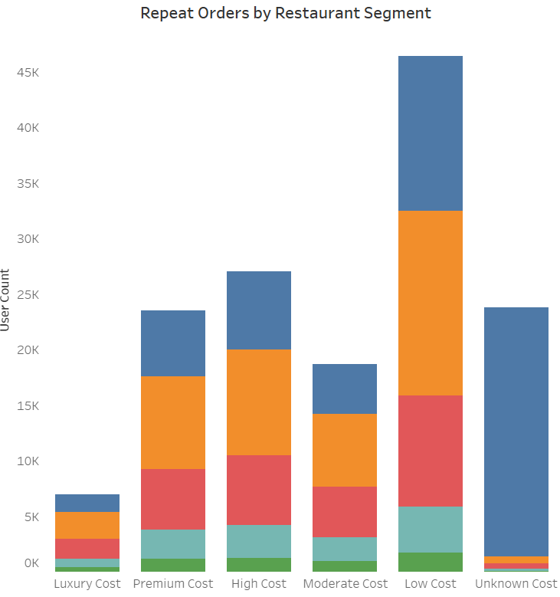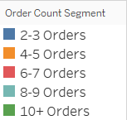

Categorizing order frequency by restaurant cost segments illustrates which income groups and restaurant price segments see **repeat customers**:

* + - **Lower-cost** restaurants see the highest **repeat business**.
    - **Premium and luxury-cost restaurants** have fewer repeat customers but attract **high-spending customers**.
    - This aligns with the substantial portion of **No Income & Low-Income** customers ordering from places with no ratings or moderate ratings and likely contributes to high-order frequencies in low-cost restaurants.

## Sales by Family Size:

* A pie chart with numbers and a number of people

  AI-generated content may be incorrect.Families with **3 members** contribute the highest sales **($6.83M**), followed by families with **2 members ($6.03M)**.

Figure 6

* Larger families (**4-6 members**) contribute less to total sales, despite having a significant user base.
* **Single-person households generate the lowest sales** ($1.56M), which is expected due to lower food consumption.
* The **user count** data aligns with sales trends, families with 2-3 members are the most common and also contribute the most to sales.
* However, while **family size increases beyond 3, sales start to decline**, suggesting:
  + Larger families may cook at home more often.
  + They may be more price-conscious or prefer bulk purchases.
  + Zomato may not effectively cater to large family meal deals.

# 4. Conclusions and Recommendations

Summary of Findings & Business Insights

1. Customer Segmentation & Behavior
   * **Students**: This group dominates order frequency, particularly at low-cost and unrated restaurants.

* Business Implication: Budget-friendly options, student discounts, meal plans, and convenience-focused promotions could be highly effective.
  + **Professionals**: Likely to seek premium experiences, though they still engage with lower-cost options.
* Business Implication: Premium offerings, subscription services, and loyalty programs may drive retention and higher spending.
  + **Entrepreneurs**: Entrepreneurs tend to spend significantly more per order, especially at highly-rated restaurants. This could indicate they are not just ordering for themselves, but possibly for clients, business meetings, or office settings.
* Business Implication: Zomato could develop premium business meal plans, corporate catering options, or curated high-end dining experiences targeted at this group.
* Loyalty rewards or bulk order incentives for business-related purchases could drive further engagement.
  + **Homemakers**: Engage in bulk ordering but have lower spending per order.
* Business Implication: Family meal promotions, household-focused discounts, and loyalty rewards could increase engagement.

1. Impact of Ratings on Customer Behavior
   * Customers overwhelmingly avoid low-rated restaurants, but otherwise, ratings do not strongly influence purchasing decisions.
   * 59% of orders come from unrated restaurants, suggesting that customers prioritize affordability and accessibility over ratings.
   * Higher-income customers order less frequently but prefer highly-rated restaurants, indicating a willingness to pay for quality.

* Business Strategy Insight:
  + - * For lower-income groups: Price and convenience are more influential than ratings. Targeting these customers with discounts and affordable meal bundles would be more effective than emphasizing restaurant ratings.
      * For higher-income groups: Highly-rated restaurants should be marketed as premium dining experiences, with curated selections, VIP benefits, or exclusive menus.

1. Order Frequency & Restaurant Cost Segments
   * The most frequent repeat customers order from low-cost restaurants, aligning with the dominance of students and lower-income users in the Sankey chart.
   * Higher-income customers place fewer orders but spend more per transaction, particularly at highly-rated restaurants.
   * Most purchases from unrated restaurants suggest either a lack of enough ratings for popular restaurants or that customers simply do not prioritize ratings.

* Business Opportunity:
  + - * Encourage reviews & ratings: Zomato could improve transparency by encouraging customers to leave ratings on frequently ordered-from restaurants.
      * Increase awareness of premium options: If highly-rated restaurants appeal to higher spenders, targeted promotions for these customers could drive engagement.

1. Family Size & Spending Patterns
   * Families with 2-3 members have the highest total sales, while larger families (4+ members) contribute less despite having a significant user base.
   * Smaller families are the most active customers, meaning meal deals and promotions should focus on them.
   * Larger families may be more price-conscious or cook at home more often.

* Key Opportunities:
  + - * Family Meal Promotions: Exclusive offers for larger families could increase their order frequency.
      * Subscription or Bulk Order Incentives: Encouraging bulk orders or pre-set family meal plans could improve spending among bigger households.
      * Marketing Focus on Small Families: Since families of 2-3 members drive the most revenue, tailored retention strategies, special discounts, and personal recommendations should be prioritized.

Key Business Opportunities for Zomato

1. Price & Affordability Strategies
   * Student-Focused Meal Plans: Discounts and affordable meal options designed for students.
   * Budget-Friendly Promotions for Lower-Income Users: More emphasis on affordability rather than high restaurant ratings.
2. Premium Market Strategies
   * Exclusive Offers for High-Spending Customers: Premium meal bundles, curated restaurant experiences, and concierge-like services for professionals and entrepreneurs.
   * Increase Visibility of Highly Rated Restaurants: Higher-income customers spend more per order but order less frequently—strategic marketing could boost engagement with premium venues.
3. Improving Customer Engagement & Ratings
   * Encourage Restaurant Ratings & Reviews: Since orders are from unrated restaurants, Zomato should incentivize reviews to improve customer decision-making.
   * Highlight Restaurant Quality for Higher-Income Users: If ratings matter more to high-income users, targeted ads highlighting top-rated restaurants could increase their spending.
4. Enhancing Family-Oriented Marketing
   * Promotions for Larger Families: Special pricing for family meal deals, bulk discounts, and loyalty rewards for households.
   * Retention Strategies for Smaller Families: Since 2-3 member families drive the most sales, engagement tactics (such as meal recommendations based on order history) could boost loyalty.

# Appendix

## Data Sources:

Zomato Data.Zip (2020). Zomato Restaurant and Customer Dataset. Retrieved from [https://tripleten.com/trainer/bi-analyst/lesson/3d4c5ff8-01b8-4f46-a9a1-f284028127d5/]

# References

Adams, C., Alldredge, K., & Kohli, S. (2024, June 10). *State of the Consumer 2024: What’s now and what’s next*. Retrieved from www.mckinsey.com: https://www.mckinsey.com/industries/consumer-packaged-goods/our-insights/state-of-consumer

Kapoor, D., & Duggal, J. (2022, May). *Report_on_State_of_Inequality-in_India_Web_Version.pdf*. Retrieved from Insitute for Competitiveness Website: https://www.competitiveness.in/wp-content/uploads/2022/05/Report_on_State_of_Inequality-in_India_Web_Version.pdf